ASSESSMENT OF FOREST STRUCTURE AND GEOGRAPHIC VARIATIONS FOR QUALITY TRAITS IN DIPTEROCARPUS INDICUS BEDD. ALONG WESTERN GHATS OF KARNATAKA, INDIA.
Thesis submitted to the University of Mysore
in fulfillment of the requirements for the Degree of

DOCTOR OF PHILOSOPHY
In
ENVIRONMENTAL SCIENCE

By

Mr. NAGEEB ALI SAEED AL-SAGHEER
M.Sc., FORESTRY

Under the Guidance of

Dr. A.G. DEVI PRASAD
M.Sc. (Botany), M.Sc. (Sus. Dev), PGDEP, Ph.D.,

Department of Studies in Environmental Science,
University of Mysore, Manasagangotri,
Mysore-570006
INDIA
2011
Summary
Variation in species richness and diversity at a local scale are affected by a number of complex and interacting variables, including both natural environmental factors and human-made changes to the local environment. Therefore, the main aims of this work were investigating how forest structure, species composition and regeneration varied among populations of Dipterocarp forests. Variations in growth and wood qualities of Dipterocarpus indicus were also investigated under different environmental gradients. Based on these objectives, the important conclusions can be summarized as follows:
5.1 Forest structure and species composition
- Based on the findings of our investigation, we conclude that environmental variables, rather than human disturbances are the main drivers of spatial variation in wood species richness and diversity among the populations of dipterocarp forests.
- The study indicates that there is scope for tree species conservation of Dipterocarp forest.
- The most important determinants of woody species richness and diversity at different populations were identified. Geoclimatic, edaphic and human disturbance variables were used to determine the variations in species richness and diversity among different populations of Dipterocarp forests.
- In total, 1051 trees with ≥ 10 cm dbh were measured with 135 species belong to 80 genera and 49 families in eight populations (eight quadrat 20 × 20 m in each population) of Dipterocarp forests. Overall results from stepwise statistical and diversity analysis showed that the environmental and human variables were by far the most important in explaining the variation in species richness and diversity among populations. The population structure and species composition of Mudigere and Makuta had the greatest number of genera, species and families. These populations were found to be distinct (niche) with high number of rare species as compared with other populations. Forest structure of Makuta, Mudigere and Sringeri showed the highest Density, basal area and number of individuals as compared with other populations.
- The Dipterocarpaceae family and Dipterocarpus indicus were dominant among the tree species and families in the studied populations of Dipterocarp forests.
- The frequency of tree species was high in the first category with diameter classes (10-30 cm) and height 15-20 m.
- A total of 1243 seedlings with ≤ 10 cm dbh) belong to 99 species and 48 families were identified in eight tree populations (thirty two plots 2 × 2 m in each population) of Dipterocarp forests.
- There were differences in the species richness and regenerate species among different populations. The populations of Mudigere and Sakleshpura have the highest species richness of regenerated species. Similar trend was observed in the same population for diversity indices (Shannon’s and Jaccard’s indices). Population of Sringeri seems to be unique in its structure and composition with high dissimilarity compared to the other populations. The patterns of species richness of regeneration were compared among populations.
- The distribution of seedling, sapling, poles and young trees showed inverse J shaped indicating the continuation reproduction mechanism of tree species in all populations. Seedlings of Dipterocarpus indicus and Dipterocarpaceae dominated regenerated tree species in all study sites except populations of Gundya and Sampaje. The highest cumulative disturbance parameters were recorded in the populations of Sringeri and Devimane whereas the lowest disturbance was recorded in the populations of Mudigere and Makuta. Inspite of this, the regenerated seedlings structure showed normal trend and the future population will be stable if the disturbance doesn’t exceed the present level.
  - Growth performance and wood quality of Dipterocarpus indicus
- Significant variation was found in height, clear bole, bole volume and bark thickness of Dipterocarpus indicus among different populations. Selection of particular girth, species and dominance reduced the variation in dbh, basal area, crown length and width among different populations.
- Strong correlation was observed among organic carbon, available nitrogen, phosphorus and potassium with growth traits. Future research should extend to investigate the additional tree species and varying site conditions on further Dipterocarp forests to achieve information on growth behaviour of these endangered and important ecosystems on sustainable management and future silviculture approaches. This could be one basis to develop sustainable management operations in order to reserve these endangered ecosystems.
- The wood physical properties of Dipterocarpus indicus showed significant variation among different populations. Specific gravity, density and moisture content were affected by environmental factors. The maximum SG and density were recorded in the core samples collected from the population of Sakleshpura and Kattalekan whereas the minimum SG and density were recorded in Kattalekan and Sampaje.
- The correlation matrix showed that the SG was correlated negatively with moisture content and geo-climatic factors. Therefore, the wood was classified based on the SG into light, moderately heavy and very heavy. The variation in wood quality of Dipterocarpus indicus resulted from the variation in locality factors among different populations. These variations in physical wood properties could be efficient and would be utilized for population selection for further tree improvement programmes.
- The variation in wood elements and anatomical ratio of Dipterocarpus indicus was significant in overall populations except in case of LV. The Causes of variations in wood Physical properties attributed to the variation in environmental gradients as well as genetic control. Less variation was found in Sringeri, Sampaje and Sakleshpura compared to the rest of populations. This study suggested that Wood elements and anatomical ratio of Dipterocarpus indicus are the main traits to consider in clone selection to improve wood quality in natural populations.
- The populations of Makuta had the maximum mean value of FD, CWT, LV and DWT whereas the populations of Kattalekan and Gundy had the maximum mean values of FL, and LD.
- In the present study, all populations showed undesirable RR for pulp wood (>1) and Slenderness ratio (>50). The variation in wood elements and anatomical ratio of Dipterocarpus indicus among populations are not desirable for pulp wood but could be suitable for plywood.
- Height, specific gravity and density were found to be significant among the three girth classes (intra-variation). These traits could be controlled by genetic drivers.
- Therefore, we are suggesting the populations with high CV per cent for selection and tree improvement programmes.
- The fast growth could also have increasing proportion of juvenile wood, which is undesirable in sawn timber products as well as in pulp yield and paper products.
- Usually, the growth, yield and wood properties (wood density) have been studied as variables independent from each other even if some of these properties may have a significant relationship among them. In this sense, the improvement of one trait may affect the others, thus, selection based on one trait could simultaneously affect other properties. For example, wood density can be used as an indicator of fibre morphology, since many studies showed that the latter one has a strong effect on the wood density. Therefore, the selection for wood traits should be considered with genetic, environmental and silivculture factors.
- Serious steps should be taken in order to conserve and manage the natural forest resources for sustainable utilization and conservation. The interaction between genetic, environment and silvicalure factors affecting the final wood products should be taken into consideration during selection programmes.
Introduction
Forests covered about half of the earth’s surface up to the development of early civilizations but today cover less than one-third of that area (FAO, 1993). Massive forest clearances were a feature of many early cultures, including ancient Assyria, Babylon, China, Egypt, Greece and Rome. Much of this forest clearance was to provide land for agriculture, although these societies were also voracious consumers of wood for cooking, heating, copper smelting, pottery making, brick-firing, house construction and shipbuilding, and this led to deforestation wherever the forest did not have the opportunity to regenerate. For more than 10000 years the forests of the Mediterranean region have been cleared; they now cover about one-sixth of the region and those that remain, often on land that cannot readily be cultivated, have been degraded by humans and their animals through unmanaged grazing.
1.1 State of the world’s forests.
Global deforestation is widely recognised as one of the world’s leading environmental problems (Dobson et al., 1997; Brook et al., 2003; Sodhi et al., 2004). Landuse change, habitat fragmentation and deforestation are listed as the biggest threat to global biodiversity (Houghton, 1991). These factors are often associated with village communities in protected areas, but the extent and intensity of such impacts are often inadequately assessed (Karanth, 2006). Forests contain high levels of biodiversity, with tropical forests being particularly important in terms of both species richness and their concentration of endemic species (Mittermeier et al., 1998; Mittermeier et al., 2003; Kier et al., 2005; Brooks et al., 2006). The world’s forests are globally important carbon pools and provide a wide variety of other ecosystem services, such as protection of fisheries, watersheds and soil (Gullison et al., 2007). Approximately 30 per cent of the global land area is currently forested and 13 million hectares are deforested per year. This is only partly compensated by the 6 million hectare of new forests established annually (FAO, 2005). Approximately more than one-third of all forests are considered primary, but approximately 60,000 km² of this primary forest is lost or modified every year. Globally the annual loss of all types of forest cover was about 130,000 km² per year between 2000 and 2005, almost half of which was offset by activities like afforestation, reforestation and re-vegetation (FAO, 2006). Most of the deforestation takes place in developing countries and in the tropics. Roughly half of the world’s forests are located in the tropics and subtropics and other half in the temperate and boreal regions. Half of the forests are in the developing countries whereas the other half is located in the developed countries (FAO, 2010). Tropical deforestation has been offset to some extent by the increase in the world’s temperate and boreal forests, but the overall size of global forests is declining. Estimated net annual decline in the forest area globally in the 1990s was 9.4 M ha (million hectare), representing the differences between the annual deforestation of 14.6 M ha and the annual afforestation of 5.2 M ha (FAO, 2001). There are 20 major forest types of the world, which are represented in the 2000 Global Forest Map (GFM) (UNEP-WCMC, 2000; Hansen et al., 2006). The 20 major forest types are rather general units (e.g., broadleaf evergreen forest) and can only provide limited information on variations in species diversity and levels of endemism across different biogeographic regions of the world. However, it is indisputable that the current deforestation rates threaten the biological diversity of forests around the globe, and jeopardise the continued supply of ecosystem services they provide (Brook et al., 2003; Fearnside, 2005; Millennium Ecosystem Assessment 2005; FAO, 2006). The updated GFM estimates global forest cover as 39.0 million km² at the 10 per cent tree cover threshold (28.8 per cent of the global land area excluding lakes, rock and ice). If the 30 per cent tree cover threshold had been selected then the area of forest cover would be reduced to 32.0 million km² (23.6 per cent of the global land area) (Fig. 1.1).
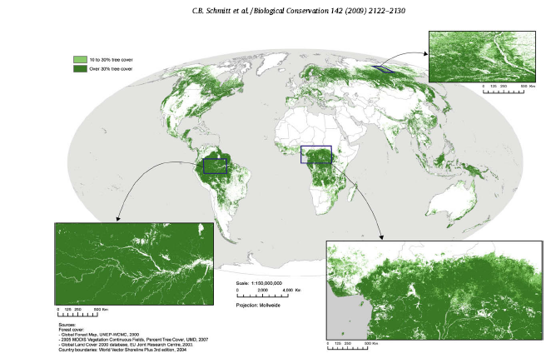

Fig. 1.1 Global natural forest area. Source: (Schmitt et al. 2009)

The updated GFM assigns 71 per cent of the world’s forest cover (i.e., 27.7 million km² of forest area) to one of the 20 forest types defined by the original GFM. Furthermore it contains 11.3 million km² of unresolved tree cover, i.e., additional forest areas identified by Schmitt et al. (2009).
1.2 Tropical forests of the world
Tropical deforestation is caused by range of factors that vary at global and local contexts (Angelsen and Kaimowitz, 1999; Geist and Lambin, 2002). Between 1990 and 1997, about 5.8 ± 1.4 million hectares of tropical humid forests were lost per year, and annual deforestation rates of tropical moist deciduous and tropical dry forests was about 2.2 and 0.7 million hectares, respectively (Mayaux et al., 2005). Tropical forests, while occupying only one-tenth of the world’s land area, are disproportionately important in terms of global biogeochemical cycles and are home to more than half of the world’s species (Fig. 1.2). They have received much attention in the recent years because of their species richness, high standing biomass and great productivity in terms of standing biomass which act a major carbon sink (Whitemore, 1984). These forests accounts for 52 per cent of the total forest area of the world. Of which, 42 per cent is dry forests, 33 per cent is moist forests and 25 per cent is wet rain forests (FAO, 2007). The tropical forests also provide vital environmental services such as helping to protect watersheds in terms of water retention, flood protection, helping to prevent soil erosion, nutrient and carbon cycling, influencing local and global climate functions, and so on (Pearce, 1991; Perrings, 2000). The rate of tropical deforestation appears to have accelerated over recent decades. For instance, during the late 1970s 6,540,000 hectares of closed forests were deforested annually, but this rose to 14,220,000 hectares by the late of 1980s (Pearce, 1991). Asian tropical forests are being destroyed at an alarming rate (Laurance, 2007). Over harvesting of forest products by local communities is among the reasons cited for loss of forest cover (World Bank, 1993).
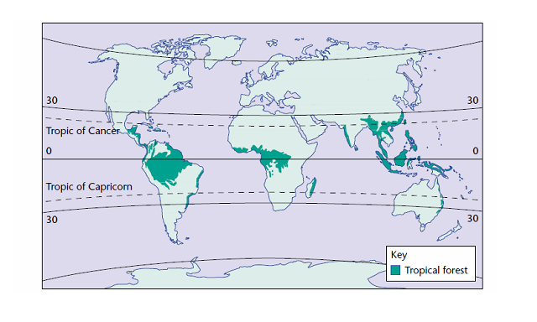
Fig. 1.2 Global distribution of tropical forests (Source: Encyclopedia of Life Sciences 2002).

CONTENTS
CHAPTER- 1- INTRODUCTION 1-22
1.1 State of the world’s forests. 1
1.2 Tropical forests of the world 4
1.3 State of the Asia’s forests 5
1.4 State of the Indian forests 7
1.5 Growth and wood traits 17
CHAPTER- 2- REVIEW OF LITERATURE 23-58
2.1 Geographical distribution and habitat of Dipterocarpus
Indicus 23
2.2 Phonotype description 24
2.3 Forest structure and species composition 25
2.4 Impact of disturbance on forest structure and species
composition 42
2.5 Regeneration studies 44
2.6 Growth performance and wood quality traits 49
2.7 Environmental conditions and wood quality traits 57
CHAPTER- 3- MATERIALS AND METHODS 59-92
3.1 Forest structure and composition 59
3.2 Measuring forest stand structures 65
3.3 Measuring forest compositions 69
3.4 Disturbance 74
3.5 Regeneration studies 76
3.6 Inter-population variation in growth and wood quality of Dipterocarpus indicus 79
3.7 Intra-population Variations in growth and wood traits 89
3.8 Statistical analysis 90
CHAPTER- 4- RESULTS AND DISCUSSION 92-203
4.1 Floristic structure of Dipterocarp forests 92
4.2 Floristic composition of tree species 97
4.3 Association of species richness, diversity and
ecological factors 115
4.4 Anthropogenic disturbance and regeneration 117
4.5 Regeneration studies 122
4.6 Locality factors as source of Variations among
populations 139
4.7 Inter-population variation in growth and wood quality of Dipterocarpus Indicus 142
4.8 Intra-population variations among different Girth classes 183
4.9 Developing strategies for sustainable management 193

CHAPTER- 5- SUMMARY AND CONCLUSIONS 204-209
5.1 Forest structure and species composition 204
5.2 Growth performance and wood quality of
Dipterocarpus indicus 206

REFERENCES 210- 247
ANNEXURES 248-249
APPENDIX

