**论文分类号：P618 单位代码：10183**

**密级：公开 博士生学号 :9200761119**



吉 林 大 学

博士学位论文

**也门共和国西北地区Wadi Sharas造山型金矿床研究**

**Study on Orogenic Gold Deposits in Wadi Sharas, Northwestern of Republic of Yemen**

作者姓名：MOTEEA ANWAR ABDULLMALIK

AL-SHAMEERY

专 业：矿物学、 岩石学、 矿床学

Major: Mineralogy, Petrology, Ore deposit

研究方向：矿床地质学

导师姓名： 孙丰月 教授

培养单位： 地球科学学院

**2012年5月**

**Summary**

My Ph.D program is planned to be done in Wadi Sharas gold deposit at Hajjah city, northwestern Republic of Yemen. The orogenic gold deposit occurs in Neoproterozioc Hajjah metamorphic belt (Nabitah orogenic belt). Gold minerals are found mainly as native metale into types of ore zones .i.e.

1) Gold deposit in quartz veins; 2) Gold deposit in disseminated sulfides and quartz veinlets and 3) Gold deposit in disseminated to massive base-metal sulphide.

The aims of this study are to: (1) address the geochemistry and origin of the ore fluids involved in the Group of the Sharas gold deposit; in order to explain the geochemistry of the ore bearing fluids, (2) determine the paragensis sequence and characterize ore minerals in the deposits, (3) provide data on ore depositional conditions, (4) characterize each mineralizing event and the evolution of Au-bearing ore fluids, (5) to establish genesis models for the deposits, emphasising structural control, hydrothermal alteration and characteristics of the mineralizing fluids, and (6) identify the distribution of gold, its chemistry, paragenesis and mineralogy to provide a mineralogical basis of ore processing. Meeting these aims will help to identify differences between mineralized and barren systems and to constrain the favorable environment for localization of similar gold mineralization.

**اسم الجامعة : جامعة جيلين-الصين**

**اسم الطالب: د. مطيع انور عبد المالك الشميري**

**عنوان الاطروحة: دراسة لرواسب الذهب في منطقة وادي-شرس حجة**

محتوى **الاطروحة**

الباب الاول: المقدمة

الباب الثاني: الجيولوجية الاقليمية

الباب الثالث: جيولوجية الخام

الباب الرابع: موديل الخام

الباب الخامس: الاستنتاجات

**المختصر**

ان رواسب الذهب في منطقة وادي شرس-حجة عبارة عن رواسب لاحقة تكونة في انطقة القص والصدوع القاطعة للصخور البركانية والرسوبية المتحولة البروتيروزويكية . يتواجد بشكل مرئي وغير مرئي.

**الاستنتاجات**

1. رواسب الذهب مصاحبه لنطاق القص والصدوع
2. ان رواسب الذهب تكون عند درجة حراره مابين 180-380 درجة مئوية وعند ضغط من (400-600) ميجا باسكل وعمق 6 الى 7 كم بلاضافة الى الملوحة wt%1-22
3. مساحة تواجد الذهب تقدر 30كم طول 2كم عرض
4. بلغت نسبة الذهب الثر من 5جرام /الطن مع تواجد قيم عالية لرواسب العناصر النادرة

**也门共和国西北地区Wadi Sharas造山型金矿床研究**

姓 名：MOTEEA ANWAR ABDULLMALIK

AL-SHAMEERY

导师姓名：孙丰月 教授

专 业：矿物学、 岩石学、 矿床学

研究方向：矿床地质学

培养单位：地球科学学院

**摘要**

造山型含金石英脉系统构成一类后生贵金属矿床，他们形成于太古代至新生代的同构造和附近的峰期变质俯冲增生杂岩中，有超过3亿年的地球历史跨越。这一类金矿床是典型变形，变质的中成地壳块体，特别是在空间上与主要地壳构造有关。

Wadi Sharas造山型金矿位于也门西北部，哈杰区东北部，新元古代的阿拉伯 - 努比亚地盾（ANS）西北部的哈杰绿岩带，目前正在勘探中。区域上包含了大量的后生金矿床，赋存在变质地体变形绿片岩内，构造走向NNW，倾向NE。控矿的去域信构造带变质火山沉积组合和变质火山组合之间的接触部位带。Wadi Sharas地区被为倾向NE的俯冲带之后的残余的新元古代岛弧或大陆边缘弧。这些层序中侵入了钙碱性和碱性的泛非（600Ma）岩体，包括辉长岩、伟晶岩、花岗岩。研究的矿床（Wadi Sharas 1，Wadi Sharas 2和Alharirah）金成矿作用在变质火山沉积岩中发生。成矿出现在后峰期变质，受构造控制。

哈杰绿岩带是新元古代Afif地块（Nabitah造山带）金矿成矿作用的关键地区。新元古代，阿拉伯 - 努比亚地盾的岩石基本上都是年轻的，在性质上，是来自地幔源产生的新大陆地壳。

在阿拉伯和非洲东北部新元古代阿拉伯 - 努比亚地盾的特点是有两个主要类型的变形带。老的变形带是东至北东向蛇绿岩的弧弧缝合线，是在大约800至700 Ma之间，由洋内岛弧和弧后地体发生碰撞的过程中形成的。唯一的例外是阿拉伯地盾东部缝合线为NW向。年轻的变形带，被称为后增生的结构，N 至NW向构构造，横切弧弧缝合线。这些变形带缩短了阿拉伯 - 努比亚地盾与冈瓦纳古陆的东、西交汇部分。在阿拉伯 - 努比亚地盾后增生构造包括（包括其他构造）由于670-610Ma E至W定向缩短发育的N向缩短直立褶皱，以及形成于约640-560Ma的NW向左旋的走滑断层（Abdelsalam, 1994）。这项工作涉及老的缝合构造上叠加的N向缩短区和NW向走滑断层。

阿拉伯地盾西部Afif地块和Hijaz-Asir洋弧地块的碰撞产生了Nabitah造山运动（Nabitah造山带），于约640Ma结束。绿片岩和角闪岩相Wadi Sharas 1，Wadi Sharas 2和Alharirah中的镁铁质和长英质岩石是拉斑至钙碱性的，具有典型的弧地球化学特征。

哈杰绿岩带代表一个古老的火山岛弧，演化历史复杂，其中包括两期区域变质作用，三次主要的花岗岩浆侵入，以及与两大变形事件有关的四世构造。主要的区域变质作用是低P-T事件，一般属于绿片岩-角闪岩相。

剪切带与早期的区域变形事件（D1）有关，这也造成了NW面理和E-W向的褶皱。第二次区域变形阶段（D2）导致了在NNE向发育弱的右旋剪切带和NS向寄生褶皱。NW向的脆性断裂形成于D1和D2韧性构造之后。

区域和岩相学观察表明，变质火山岩局部受青磐岩化和绢云母蚀变影响。变沉积岩普遍发育硅化，绢云母化，碳酸盐化。变质火山沉积岩和岩脉/岩床也被矿化带中的方解石±石英细脉切割。

角闪岩，黑云石英片岩的地球化学特征表明至少有两个不同的前碰撞构造环境，在阿拉伯地盾的碰撞时期并置。这一新的证据提出至少有一个明显的新构造意味着Wadi Sharas碰撞前的历史。在哈杰蛇绿岩岩石年龄和地球化学特征基础上，认为Wadi Sharas中洋（MO）在新元古代时期是一个成熟的大洋。

矿物学研究上，建立了共生序列由四个热液阶段组成（D2和D3），基本符合Wadi Sharas金矿主要变形事件。D2阶段金沉淀的主要时期，随后，D3阶段，它的特点是更加多样化矿石矿物，包括贱金属和硫化物矿物。富As的黄铁矿受控于陡倾矿体，很可能在各个深度构造连接是以通道的方式，通过富As（D3）热液向上迁移。

在上述地质研究的基础上，结合流体包裹体的研究结果和围岩的年龄，我们认为，Wadi Sharas主要成矿作用是属于造山型金矿成矿作用。与断裂带和剪切带有关的Wadi Sharas造山型金矿，处于地壳中等深度的新元古代变质沉积和变质火山沉积内，约2.3-1.3Ga，在绿片岩相条件下，联合褶皱和变质。我们相信，这些矿床的形成是沿Afif体增生或碰撞的会聚边缘，与板块俯冲相关。金低于在Wadi Sharas黄铁矿中Au的溶解度而存在被认为金成矿作用是后生起源的证据。

Wadi Sharas表壳岩由黑云母石英片岩，透闪石，绿泥石片岩，角闪片岩，蛇纹岩，大理石，石墨片岩和镁铁质 - 超镁铁质岩组成，是强烈变形的近N – S向近直立剪切带。矿床主要赋存在哈杰群中元古代变质岩中，由两套韧性剪切带构造控制。

与金矿化密切相关的是沿韧性剪切带强烈的热液蚀变，具有典型的绿片岩相蚀变组合，绢云母+绿泥石+方解石+黑云母+石英。从矿体至围岩的蚀变带为，内部毒砂 - 绢云母带，中间碳酸盐带，外部黑云母-绿泥石带。矿化位于剪切带变质沉积岩内，在空间上接近岩脉/岩床。形成于脆性条件下。硫化物组成主要为毒砂，黄铁矿，磁黄铁矿，闪锌矿，方铅矿和黄铜矿。

我们认为，目前哈杰绿岩带金矿化主要由三种类型组成：1）脉状、浸染状分布的硫化物和金，2）剪切带中含金石英脉，3）方解石硫化物石英细脉。金为细粒（2μm），与毒砂，黄铁矿和磁黄铁矿密切伴生。在毒砂，黄铁矿中以裂隙金和包裹金存在。在围岩的硅酸盐基质中也可见细粒金。金通常与毒砂，磁黄铁矿和黄铁矿共存，且局限在各种伸展的石英硫化物±碳酸盐脉中，位于近NW-SE 和NS向，陡倾的剪切带内，围岩为角闪岩相变质火山沉积岩。哈杰花岗岩包围表壳岩的狭长地带。

我们的初步观察表明，在三个研究矿床中（Wadi Sharas 1，Wadi Sharas 2, Alharirah），矿体有着类似的构造，共生组合和热液蚀变特征。矿体由白色的石英脉（> 60vol％），碳酸盐（铁白云石），电气石，绢云母和硫化物组成。

矿体延长南至Wadi Sharas，北至Wadi Alharirah，超过30公里的距离。Wadi Sharas造山型金矿热液蚀变的特点，包括钙硅酸盐蚀变，硫化，不明显的硅化，电气石化，碳酸盐化。

蚀变矿物组合表明矿床形成在绿片岩和角闪岩变质相环境，表明成矿作用在中成深度。大约90％的金矿形成在Alharirah约5km宽的接触变质带，而在Wadi Sharas 1和Wadi Sharas 2约2km范围内，其中大多数都集中在含硫化物石英脉中。

本文测试6个流体包裹体，使用吉林大学地球科学学院地质流体实验室Linkam THSM - 600型冷热台。我们得到了成矿流体均一温度，盐度，密度和压力，并计算出的典型矿床的成矿深度。

通过观测含二氧化碳气泡（密度达0.98 g/cm3）的包裹体，石英晶体中的流体包裹体形成的PT条件为温度1​​80 - 380°C和压力达400-600 MPa。假设静岩负载，估计的结晶压力约6-7公里深。盐度范围从1到22 wt％。Wadi Sharas矿床，碳酸盐-石英-金脉中，主要为含水包裹体，有少量含CO2流体包裹体。单个流体包裹体组合内的CO2包裹体均一温度的一致性，被解释为水占主导地位，少量CO2流体是碳酸盐脉和金成矿作用的成矿流体。

Wadi Sharas矿床富砷，钡，汞，钼，硫，锑，碲，铊和钒。它的经济金浓度与硫化矿物的同位素组成有关，但不与其总丰度相关。

矿化显示富集钙，总硫，砷，银，金，锑，锡，钨，铅，铋，镉，硒和汞，而钾，钠略亏损，近端矿带的热液蚀变组合是透辉石，钙质角闪石，黑云母，电气石。

本论文讨论了Wadi Sharas金矿的地质背景，岩相学，矿物学，构造，地球化学，流体包裹体分类及测试结果，这些特征支持另一种解释。以往的研究已建立的地质学，矿物学，岩石学，地球化学（浓度金属），构造和分布，但金矿物学性质和成因模型仍不完善。

本次研究的结果表明，Wadi Sharas地区金矿成因类型为造山型金矿，虽然与造山后的岩脉/岩床空间密切，但与该区的造山后岩浆活动无关。

**关键词**：

造山型金矿床，Wadi Sharas，Nabitah绿岩带，石英脉型金矿化，成矿

Study on Orogenic Gold Deposits in Wadi Sharas, Northwestern of Republic of Yemen

Author: Moteea Anwar AbdullMalik Al-Shameery

Supervisor: Sun Fengyue

Major: Mineralogy, Petrology and Ore deposit

**Abstract**

Orogenic gold quartz vein systems constitute a class of epigenetic precious metal deposit; they formed syntectonically and near peak metamorphism of subduction- accretion complex's of Archean to Cenozoic age, spanning over 3 billion years of Earth's history. This class of gold deposits is characteristically associated with deformed and metamorphosed mid-crustal blocks, particularly in spatial association with major crustal structures.

Wadi Sharas orogenic gold deposit is located in Hajjah greenstone belt in the northwestern Neoproterozoic part of the Arabian-Nubian Shield (ANS) within the northeastern part of Hajjah district, northwestern Yemen, which is currently under exploration. This region contains numerous epigenetic gold deposits hosted in deformed greenschist metamorphosed terranes, in a tectonic corridor striking NNW and dipping NE. This tectonic zone constitutes the contact between a meta-volcanosedimentary assemblage and a meta-volcanic assemblage. Wadi Sharas area has been interpreted as the remnant of a Neoproterozoic island arc or continental margin arc situated behind a NE dipping subduction zone. These sequences were intruded by calc-alkalic and alkalic Pan African (600 Ma) granites consisting of granite, gabbro and pegmatite bodies. At the studied deposits (Wadi Sharas 1, Wadi Sharas 2 and Alharirah), gold mineralization occurs in meta-volcanosedimentary rocks. It appears post-peak metamorphism and structurally controlled.

Hajjah greenstone belt is the key district of gold mineralization in the Neoproterozoic Afif terrane (Nabitah orogenic belt). The rocks of the Arabian-Nubian Shield are essentially juvenile in character, derived from mantle sources and produced new continental crust during the Neoproterozoic.

The Neoproterozoic Arabian–Nubian Shield in Arabia and northeast Africa is characterized by two main types of deformation belts. The older deformation belts are E- to NE-trending ophiolite-decorated arc–arc sutures formed during collision of intra- oceanic island arc-back arc terranes that occurred between ~800 and 700 Ma. The exception to this is the eastern part of the Arabian Shield where sutures trends NW. The younger deformation belts, which have been referred to as post-accretionary structures, are N- to NW-trending structures and crosscutting the arc–arc sutures. These belts were developed in response to shortening of the Arabian–Nubian Shield between the converging fragments of East and West Gondwana. Post-accretionary structures in the Arabian–Nubian Shield consist of (among other structures) N-trending shortening zones in the form of upright folds that developed due to E–W directed shortening at 670–610 Ma, and NW-trending sinisterly strike-slip faults, that developed at 640–560 Ma (Abdelsalam, 1994). This work deals with superimposition of N-trending shortening zones and NW-trending strike-slip faults on older suturing structures.

Collision of the Afif terrane with Hijaz-Asir oceanic arc terrane of the western Arabian Shield gave rise to the Nabitah orogeny (Nabitah orogenic belt), and was complete by about 640 Ma. Mafic and felsic rocks from both the greenschist and amphibolite facies Wadi Sharas 1, Wadi Sharas 2 and Alharirah are calc-alkaline to tholeiitic with typical arc geochemical characteristics.

Hajjah greenstone belt represents an ancient volcanic island arc and has subsequently been subjected to a complex history of evolution, including two episodes of regional metamorphism, three main pulses of granitoid plutonism, and four generations of structures related to two major deformational events. The main regional metamorphism was a low P-T event and generally belonged to greenschist-amphibolite facies.

The shear zone is correlated with an early regional deformation event (D1), which also caused NW foliations and E-W trending folds. A second regional deformation phase (D2) resulted in NNE oriented weakly developed dextral shear bands and N-S trending parasitic folds. NW striking brittle faults postdate D1 and D2 ductile structures.

Field and petrographic observations show that the meta-volcanic rocks are locally affected by propylitic alteration and sericitization. The metasedimentary rocks suffered from pervasive silicification, sericitization, and carbonatization. The meta- volcanosedimentary rocks and the dikes/sills are also cross-cut by calcite ±quartz veinlets in the mineralized zone.

The geochemical characteristics of the amphibolite and biotite-quartz-schist suggest at least two distinct pre-collisional tectonic environments which were then juxtaposed during collision of the Arabian Shield. This new evidence presents at least one distinctly new tectonic implication for the pre-collisional history of Wadi Sharas. Based on age and chemical characteristics of rocks of Hajjah ophiolite, Middle Ocean (MO) of Wadi Sharas was considered as a mature ocean during the period of Neoproterozoic.

Mineralogical studies have established a paragenetic sequence consisting of four hydrothermal stages (D2 and D3) which are generally in accord with the major deformation events at Wadi Sharas gold deposit. The D2 stage was the dominant episode of gold deposition, followed, in importance by the D3 stage, which is characterized by more diverse ore mineralogy including base metal sulfides minerals. The occurrences of As-rich pyrites are restricted to steeply-dipping ore bodies, which are most likely structurally connected at various level by channel ways through which As-rich (D3) hydrothermal fluid migrating upward.

According to the basis of the geological studies mentioned above, combining with the results of the study of fluid inclusions, we believe that the main mineralization of Wadi Sharas is belongs to orogenic gold deposit. Wadi Sharas orogenic gold deposit is related to the fault zones and shear zones vein at medium depth in the crust in the Neoproterozoic meta-sedimentary and meta-volcanosedimentary, which were jointly folded and metamorphosed under greenschist facies conditions at about 2.3-1.3 Ga. We believe that these deposits form along convergent margins during Afif terrane accretion, or collision, which were related to plate subduction. The presence of metallic Au below the Au solubility limit in Wadi Sharas pyrite is interpreted as evidence of an epigenetic origin for Au mineralization.

The supracrustal rocks in Wadi Sharas are consists of a sequence of biotite-quartz schist, tremolite, chlorite-schist, amphibolite-schist, serpentinite, marble, graphit-schist and mafic-ultramafic rocks where strongly deformed within a roughly NW-SE and N–S trending subvertical shear zone. The deposit-hosting structures crosscutting Neoproterozioc metamorphic rocks of Hajjah Group and is structurally controlled by two sets of ductile shear zones.

Gold mineralization is closely associated with intense hydrothermal alteration along the ductile shear zones, with a typical greenschist facies alteration assemblage of sericite + chlorite + calcite+ biotite + quartz and a distinct alteration zoning of inner arsenopyrite- sericite zone, middle carbonate zone, and outer biotite-chlorite zone from orebody to wall rock. The shear zone hosted mineralization crosscutting the metasedimentary rocks, in close spatial proximity to the dikes/sills. It took place under brittle conditions. Arsenopyrite, pyrite, pyrrhotite, sphalerite, galena, and chalcopyrite are the main sulfide phase components.

We originally suggested that there are three major types of primary gold mineralization are present in Hajjah greenstone belt consisting of: 1) Gold deposit in quartz veins; 2) Gold deposit in disseminated sulfides and quartz veinlets and 3) Gold deposit in disseminated to massive base-metal sulphide.

The gold is fine-grained and closely associated with arsenopyrite-pyrite and pyrrhotite. Gold is found in fractures and as inclusions in the arsenopyrite-pyrite. Gold is also seen as free grains in the silicate matrix. The gold is commonly associated with arsenopyrite, pyrrhotite and pyrite and is confined a variety of extensional quartz-sulphide ±carbonate veins within a roughly N-S striking, steeply dipping shear zone crosscutting amphibolite facies meta-volcanosedimentary rocks. The narrow belt of supracrustal rocks is surrounded by Hajjah granite

Our preliminary observations indicate that the orebodies share similar structural, paragenetic and hydrothermal alteration characteristics in all three targets (Wadi Sharas1, Wadi Sharas 2 and Alharirah). Orebodies are veins composed of white quartz (>60vol.%), carbonate (ankerite), tourmaline, sericite and sulfides.

The orebodies are extended from Wadi Sharas in the south to Wadi Alharirah in the north over a distance of some 30 Km. Wadi Sharas orogenic gold deposits are characterized by hydrothermal alteration, including calc-silicate alteration, sulphidation, and, less significant silicification, tourmalinization, and carbonatization.

Alteration mineral assemblage suggests a greenschist metamorphic facies environment and amphibolite, indicating mesozonal conditions during mineralization. Approximately 90% gold deposit in Alharirah lie within the ~5 km wide contact and ~2 km in Wadi Sharas 1 and Wadi Sharas 2, and most of these are concentrated in sulphide bearing- quartz veins.

During the period of writing the paper, six of fluid inclusions tests made, using Linkam THSM-600-type cold-hot desk in the laboratory of geological fluid of the college of the Earth Science, Jilin University. We got alot of results of ore-forming fluids homogenization temperature, salinity, density and pressure, and we can calculate the depth of mineralization of the typical deposits.

Formation P-T conditions recorded by fluid inclusions in quartz crystals correspond to 180–380 °C and 400-600 MPa, as indicated by high-density CO2 bubbles (up to 0.98 g/cm3) observed in some inclusions. The estimated crystallization pressures correspond to approximately 6-7 km of overburden. The salinity ranges from 1 to 22 wt%. The dominate of aqueous-bearing inclusions and rare occurrence of carbonic fluid inclusions in carbonate–quartz–gold veins in Wadi Sharas deposits, and the consistency of homogenization temperatures of carbonic inclusions within individual fluid inclusion assemblages, have been interpreted to indicate that H2O-dominated, CO2-poor fluids were responsible for the carbonate veining and Au mineralization.

Wadi Sharas deposits are enriched in As, Ba, Hg, Mo, S, Sb, Te, Tl and V. Its economic gold concentrations correlate with the isotopic compositions of sulphide minerals but not their total abundances.

The mineralization displays enrichment in Ca, total S, As, Ag, Au, Sb, Sn, W, Pb, Bi, Cd, Se, and Hg, whereas K and Na are slightly depleted and the hydrothermal alteration assemblage in the proximal ore zone is diopside, calcic amphibole, biotite, and tourmaline.

This thesis discusses new results of assessments of geological setting, petrographical, mineralogical, structural, geochemistry, and fluid inclusions characteristics of these gold deposits tests classifications and supports an alternative interpretation. A number of previous studies have established the geology, mineralogy, petrography, geochemistry (concentration metals), structure, and distribution, but the nature of the gold mineralogy and genesis model has remained poorly characterized.

The findings of this study suggest that the genesis of mineralization at Wadi Sharas is of orogenic gold type and unrelated to post-orogenic magmatism in the area, although a close spatial proximity to post-orogenic dikes/sills exists.

**Key words**:

Orogenic gold deposits, Nabitah greenstone belt, Wadi Sharas, quartz vein lode-gold mineralization, ore formation

## Introduction

Orogenic gold deposits are associated with regionally metamorphosed terranes of Middle Archean-Tertiary age (Goldfarb et al., 2001). Ores were formed during compressional to transpressional deformation processes at convergent plate margins in accretionary and collisional orogens. In both types of orogen, hydrated marine sediments and volcanic rocks have been added to continental margins during tens to some 100 Ma of collision (Groves et al., 1998, 2003).

The Neoproterozoic greenstone sequence in Hajjah Goldfields Province of Arabian-Nubian Shield in northwestern Yemen is characterised by trust fauld followed by strike-slip tectonics and locally fault-controlled, fluid fluxes. Fluid flow was associated with the formation of many fault-hosted and shear-zone-hosted gold deposits, which are commonly clustered adjacent to displacement faults or shear zones.

Over half of the world's gold production of 129,000 tonnes has been from orogenic lode gold deposits, also termed 'mesothermal' gold deposits (Hodgson et al., 1993; Sutton-Pratt, 1996). These orogenic gold deposits have formed sporadically over more than ca. 3 billion years of Earth's history, especially during the Neoarchean to Paleoproterozoic, and in many Phanerozoic orogenic belts. This class of gold deposit is characteristically associated with deformed and metamorphosed mid-crustal blocks, in particular spatially related to major crustal structures. Figures 1.1 shows the distribution of selected orogenic lode gold deposits, worldwide, hosted within crust of a given age. The genesis of these orogenic lode-gold deposits remains controversial, although a general consensus for an epigenetic origin has arisen during the past twenty years of intensive research (Kerrich and Cassidy, 1994; McCuaig and Kerrich, 1988; Ridley and Diamond, 2000), as against the syngenetic model of the 1970's and 80's (Hutchinson, 1975, 1987). The principal models are: (1) granitoid-related magmatic hydrothermal fluids (Burrows and Spooner, 1985; Burrows et al., 1986), (2) mantle derived fluids (Colvine et al., 1984; Fyon et al., 1984), (3) convecting meteoric waters (Nesbitt, 1988; Nesbitt and Muehlenbachs, 1991), and (4) fluids generated by metamorphic devolatilization reactions of ocean crust and sediments in subduction-accretion complexes (Kerrich and Wyman, 1990; Goldfarb et al., 1991a).

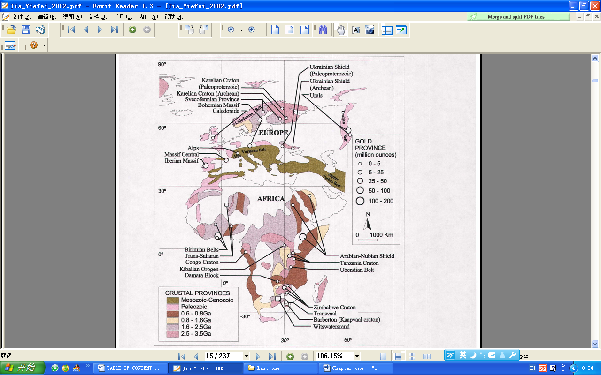

**Fig.1.1 Map showing the distribution of selected orogenic lode gold deposits hosted within crust of specified age (after Goldfarb et al., 2001). Europe, Africa and some parts of Asia**

However, since the price of gold increased during the late 1980’s the research activities became more focused on gold deposits within the Arabian Shield.

In Wadi Shars goldfield, within Wadi Sharas 1, Wadi Sharas 2 and Alharirah, fluid flow in a gold-producing hydrothermal system was localised within arrays of low displacement faults and shear zones, which form part of the NW trending, crustal-scale, Hajjah Fault System (HFS).

Wadi Sharas gold district, in the northeastern part of Hajjah city, northwestern Yemen, was known since the 1996. The numerous ore-hosting structures are kinematically related to thrust–oblique slip on Sharas Fault, which is a 20-km long splay of the 200-km-long Hajjah Fault. Most of the known gold mineralisation at Wadi Sharas occurs within an area of 30 km2. The distribution of low displacement faults and shear zones that host gold mineralisation is related to the presence of a kilometre-scale contractional Wadi Sharas and an associated imbricate thrust array on Sharas Fault.

Gold contained in the structure of the common sulfide minerals (mainly in pyrite and arsenopyrite) and present as discrete inclusions smaller than 2 μm are collectively termed submicroscopic gold or “invisible” gold, not detectable by optical and scanning electron microscopy (Moteea et al., 2011).

The regional ductile-brittle shear zone was developed along the northern part of Sharas Zone. A series of gold deposits such as Wadi Sharas 1, Wadi Sharas 2 and Alharirah are distributed in this ductile-brittle shear zone, and form a NW-SE-trending gold ore belt.

## 1.2 Topographical and climatic features

Yemen is bounded in the north by [Saudi Arabia](http://www.arab.de/arabinfo/saudi.htm), east by [Oman](http://www.arab.de/arabinfo/oman.htm), south by the Gulf of Aden and west by the Red Sea. The territory includes 112 islands including Kamaran (181 sq. km) and Perim (300 sq. km) in the Red Sea and Socotra (3,500 sq. km) in the Gulf of Aden. Yemen covers about 527,970 sq km (about 203,850 sq mi). The total population of Yemen (1997 estimate) is 21,857,186.

The climate in Yemen is various and depends on the different altitudes of the regions.  
There are no distinctive limits between the seasons. Generally there are two main seasons (summer and winter). During summer the climate is hot with high humidity dominating in the coastal area. In winter the climate in the coastal area is relatively moderate. Occasional rains in the summer are caused by the monsoon coming from the Indian Ocean.

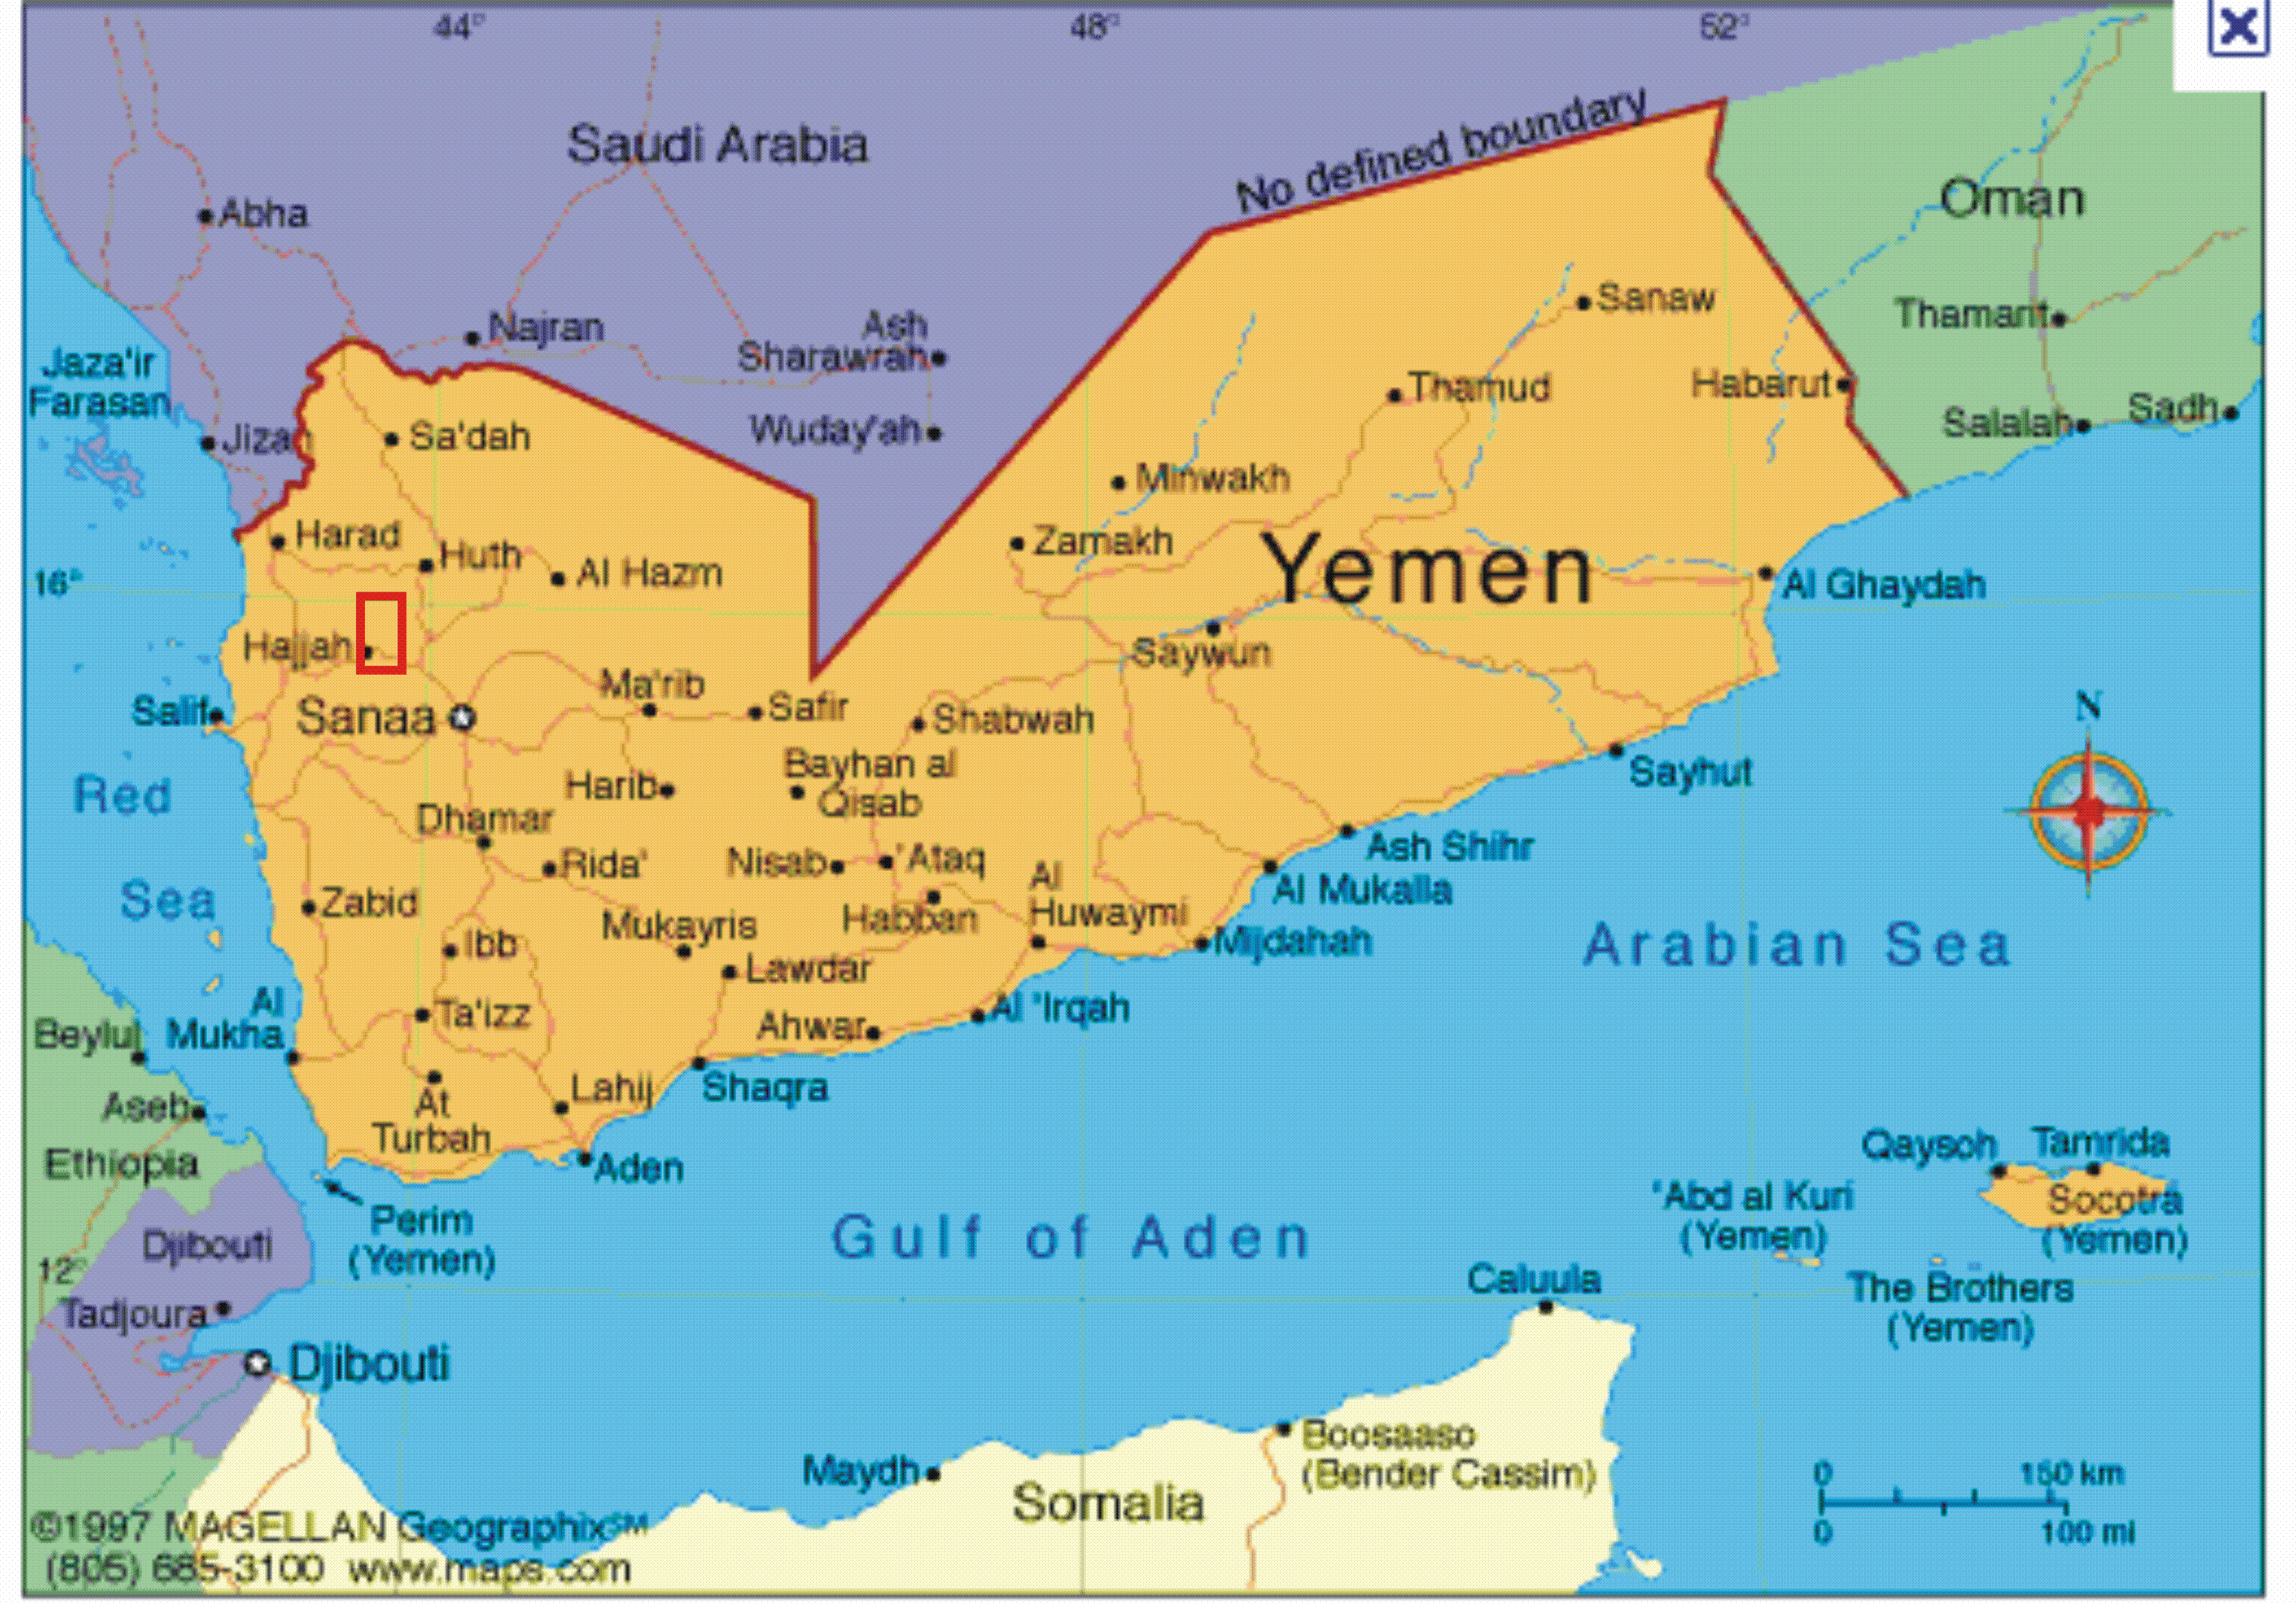

**Fig.1.2 Topographical map of Yemen showing Wadi Sharas area**

These rains decrease the high temperatures in the coastal area during the summer.

（1）The topography of Wadi Sharas district is characterized by an alternation of small valleys and hills which show in places steep slopes.

The altitudes vary between less than 20 m and about 200 m. The topographically moderate zones are located north and south of the study area, particularly in the area of Wadi Sharas 1, Wadi Sharas2 and Alharirah (Fig.1.2 and 1.3). The different landscapes of the Republic of Yemen can be grouped into four main geographical and climatologically regions:

（2）The Coastal Plains: These plains are located in the west and southwestern part of the country, and are flat and slightly sloppy with hot climate and low rainfall (<50 mm/year).

（3）The Yemen Mountain Massif: It is high with very irregular and dissected topography, with elevation ranging from a few hundred meters to 1,000 m above sea level. The climate varies from hot at lower level to cool at the highest elevation. （4）The Eastern Plateau Region: Most of the eastern half of the country is covered by this plateau. Its elevation decreases from 1200-1800m at the major watershed lines to 900m in the northern desert border and to a lower sea level on the coast. In general its climate is hot and dry.

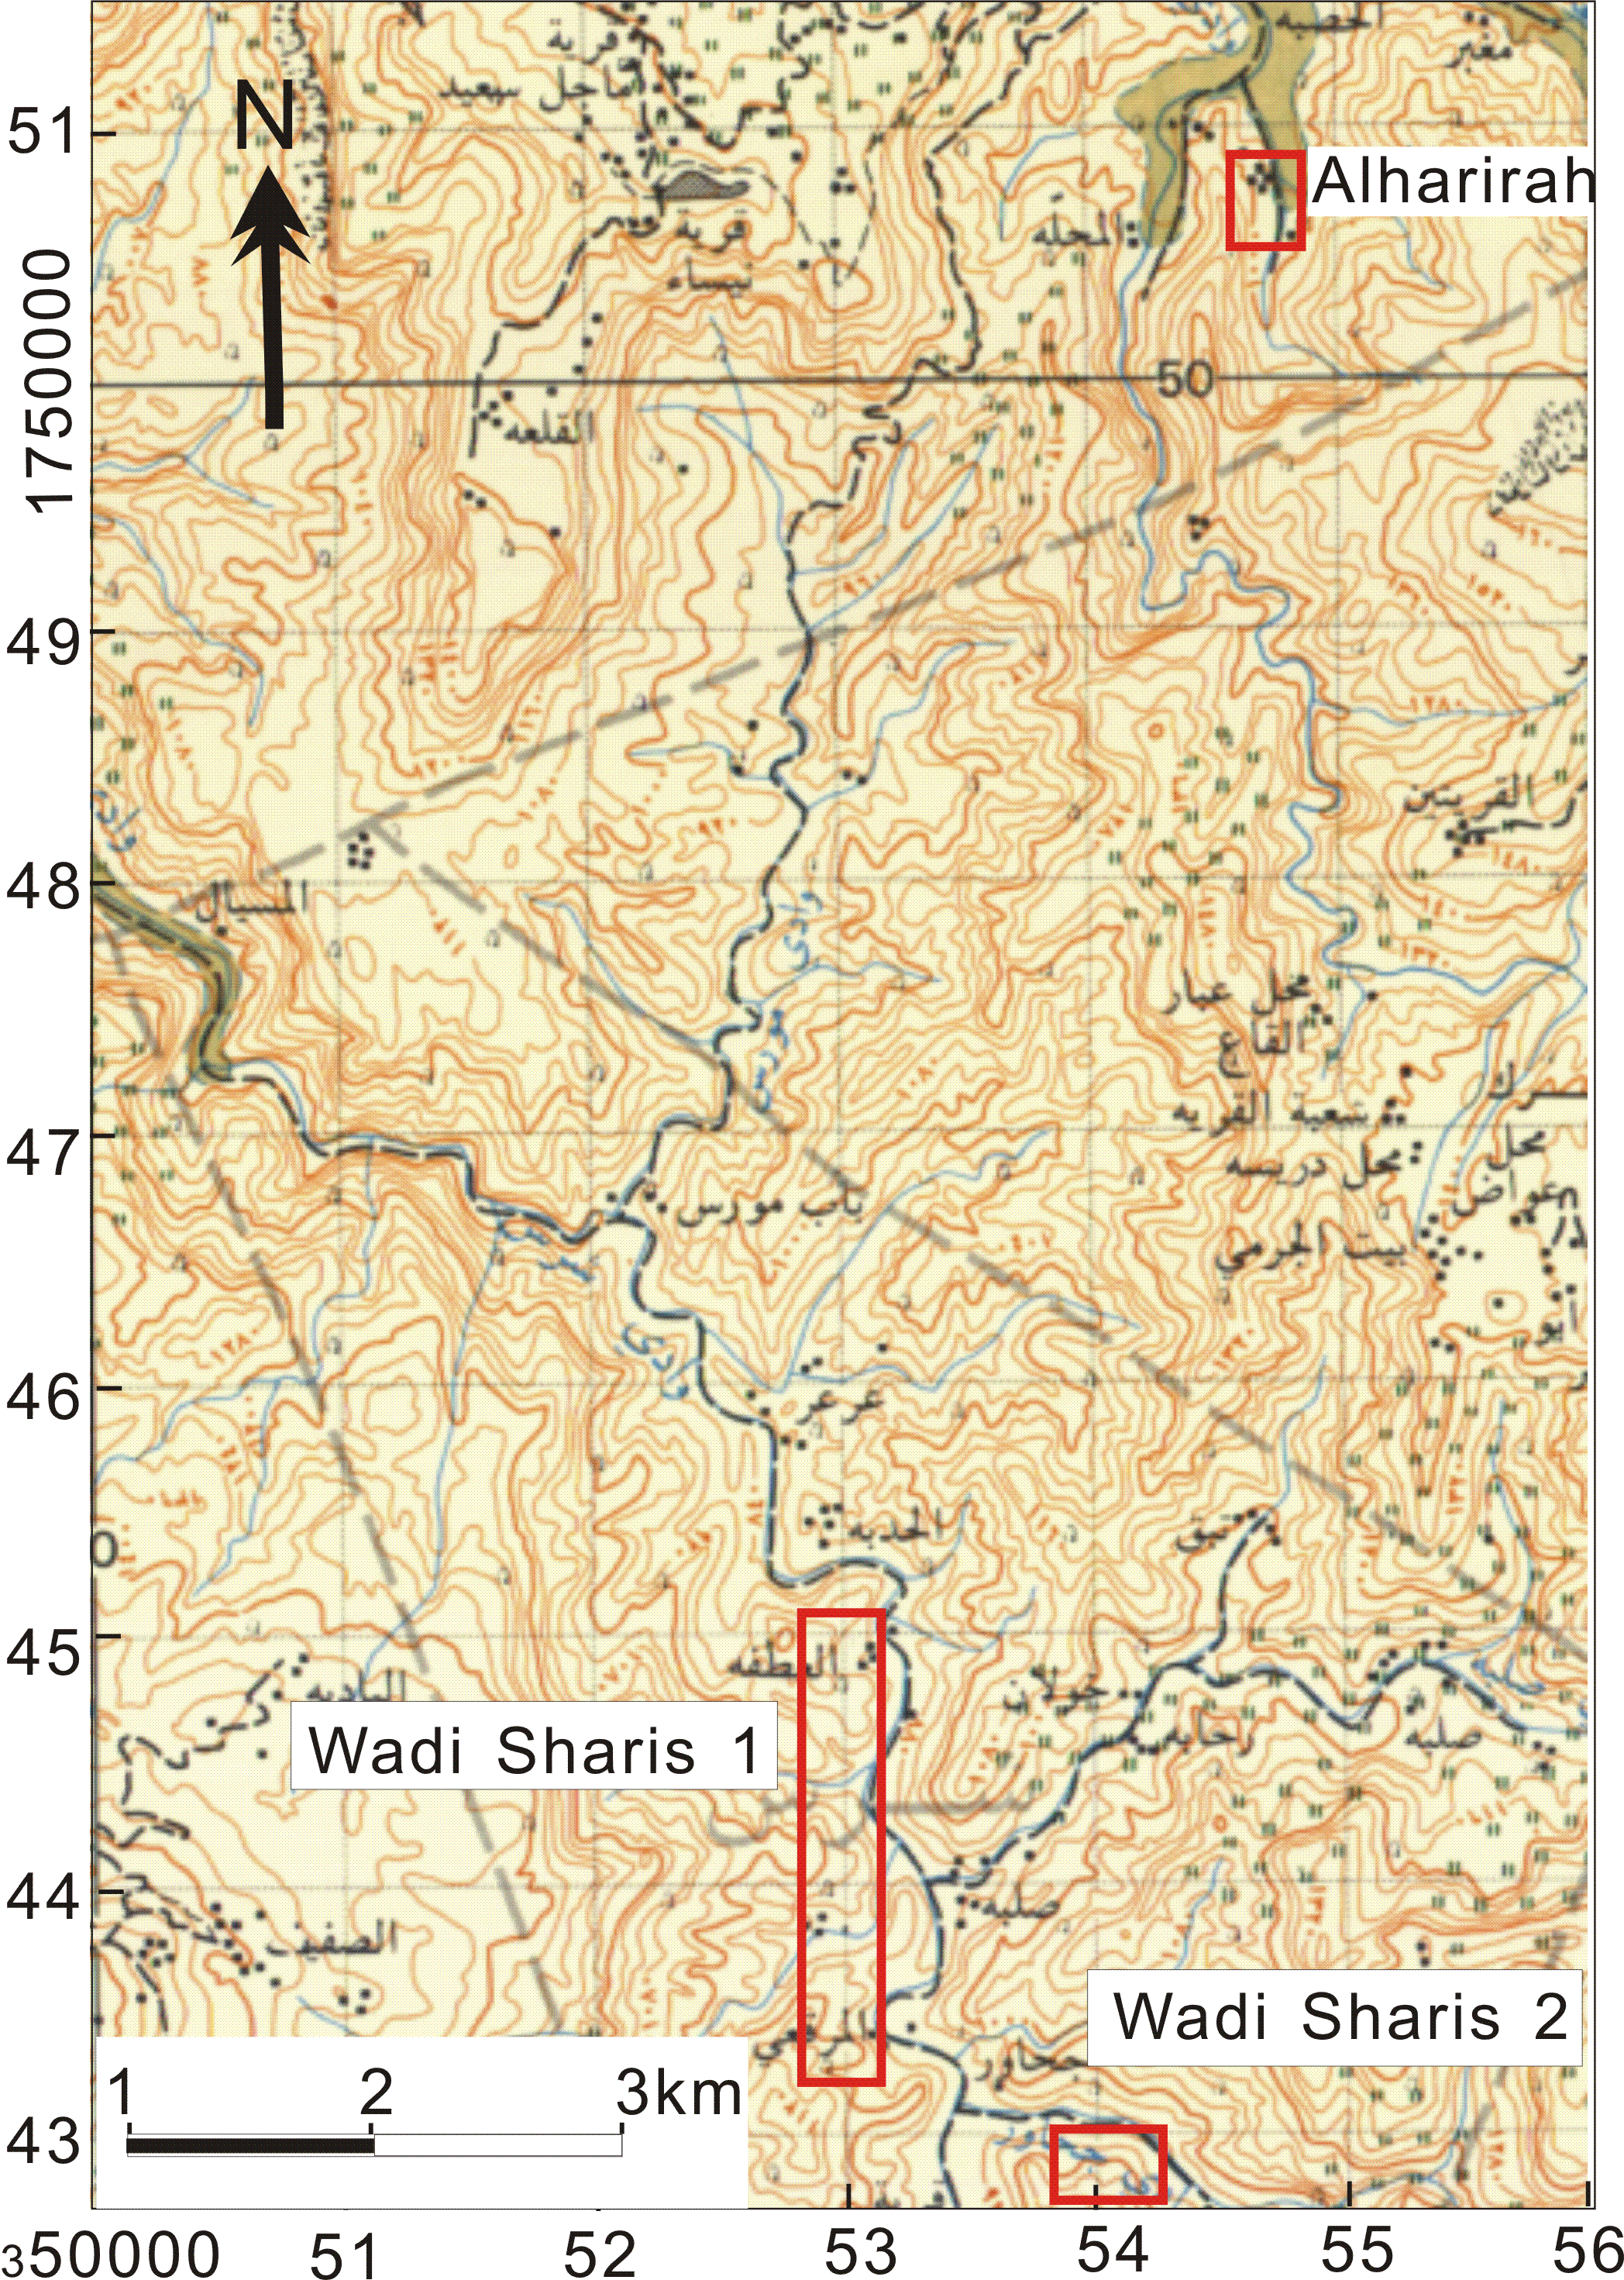

**Fig. 1.3 Topographic map of Wadi Sharas area (modified from overseas survey, 1981)**

In Tihama temperatures are high in summer (over 37 °C at daytime) with extremely high humidity. Moderate temperatures between 30 °C and 35 °C at daytime prevail in winter. In this season the humidity is lower, in the evenings and during the night it cools down. In the mountains 30°C are rarely exceeded in the hottest time of the day in summer (winter: 25 °C), caused by a constant, light wind. At night temperature drops from 8°C to 13°C; over 3000 m even to the freezing point in winter.

Hajjah is the capital city of [Hajjah Governorate](http://en.wikipedia.org/wiki/Hajjah_Governorate), northwestern [Yemen](http://en.wikipedia.org/wiki/Yemen). It is located 72.8 kilometers northwest of [Sana'a](http://en.wikipedia.org/wiki/Sana'a), at an elevation of about 1800 m. As of 2003, the Hajjah District had a population of 53,887 people. Its geographical coordinates are [15°41′42″N 43°35′51″E](http://toolserver.org/~geohack/geohack.php?pagename=Hajjah&params=15_41_42_N_43_35_51_E_type:city(53887)_region:YE). The town of Hajjah is the center of the Governorate. The town of Hajjah is among the most fortified mountainous strongholds in Yemen. The climate of Wadi Sharas is moderate in the summer (～25 ○C) and cold in the winter (+6 ○C) in the mountainous region, humid and hot in summer and moderate in winter on the coastal plain.

## 1.3 Location of the study area (Wadi Sharas)

Wadi Sharas orogenic gold deposit is located some 10 kilometers to the northeast of Hajjah city, and situated some 260 kilometers to the west of Sana’a (Fig.1.4). With geographical coordinates of 15° 45、 to 15° 51、N Latitude and 43° 36、 to 43° 40、E Longitude, the territory of Wadi Sharas covers 30 km2.

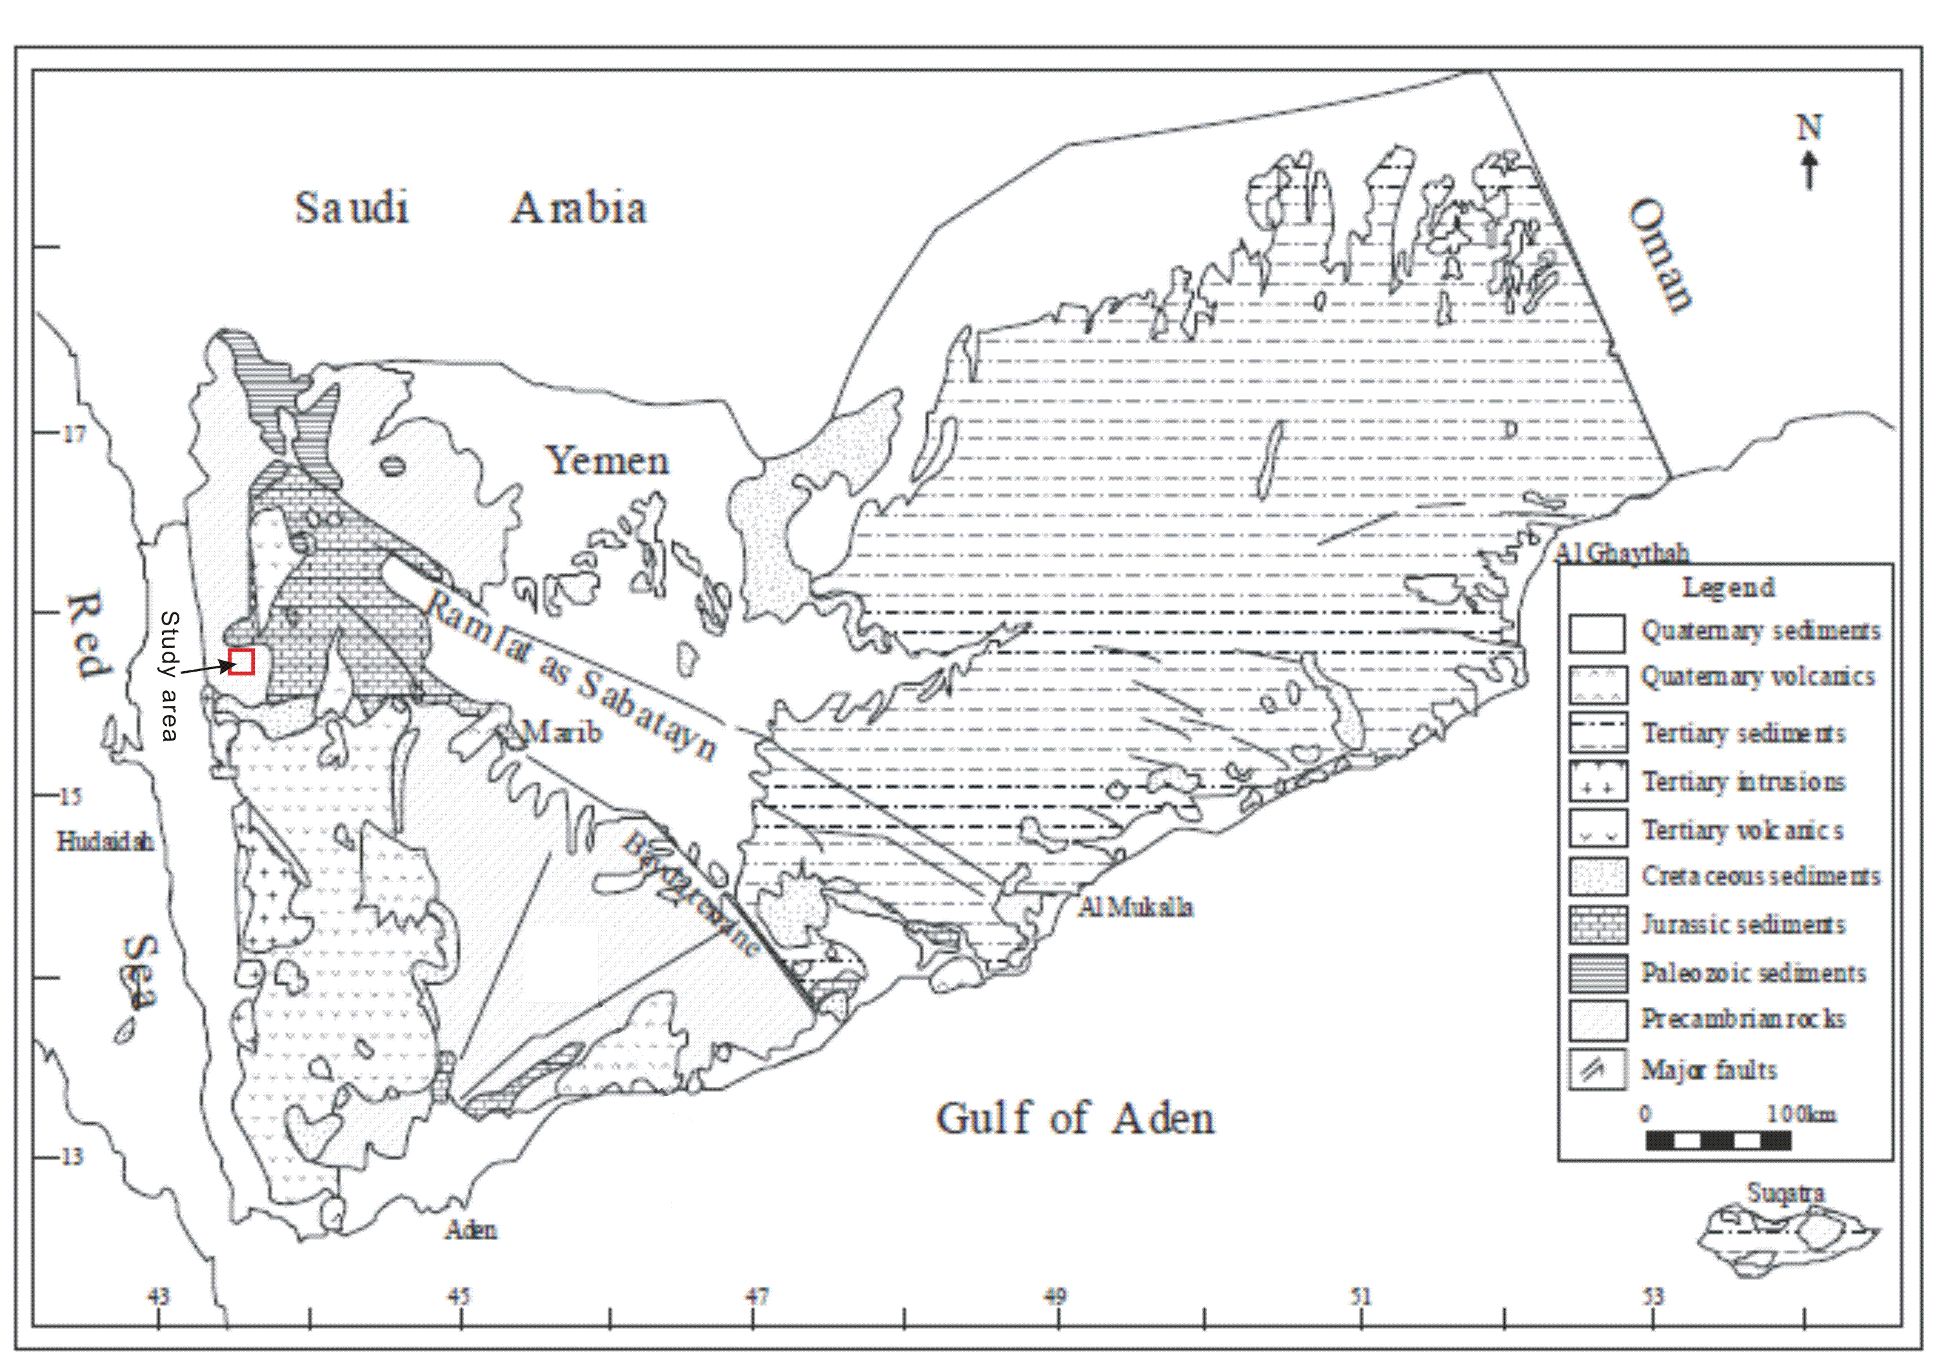

Sana,a

Hajjah

**Fig.1.4 Geological map of Republic of Yemen with location of Wadi Sharas**

**(Robertson Group 1992; Menzies et al., 1994)**

Wadi Sharas district belongs to the administrative area of “Hajjah metamorphic belt” which is located in the northwestern part of Yemen. It is easily accessible by mettalled road until Hajjah city and beyond, by dirt road for approximately 30 km. The area consists of a very dissected and mountainous terrain and lies at an elevation ranging between 900 m and 2500 m above sea level. The area is traversed by the Sana'a-Hajjah highway, and is drained by Wadi Sharas in the southern and central parts and Wadi Alharirah in the northern parts.

Conversely, the distribution of the metallic deposits in Yemen obviously provides information regarding the evolution of the ores (see Fig.1.5).

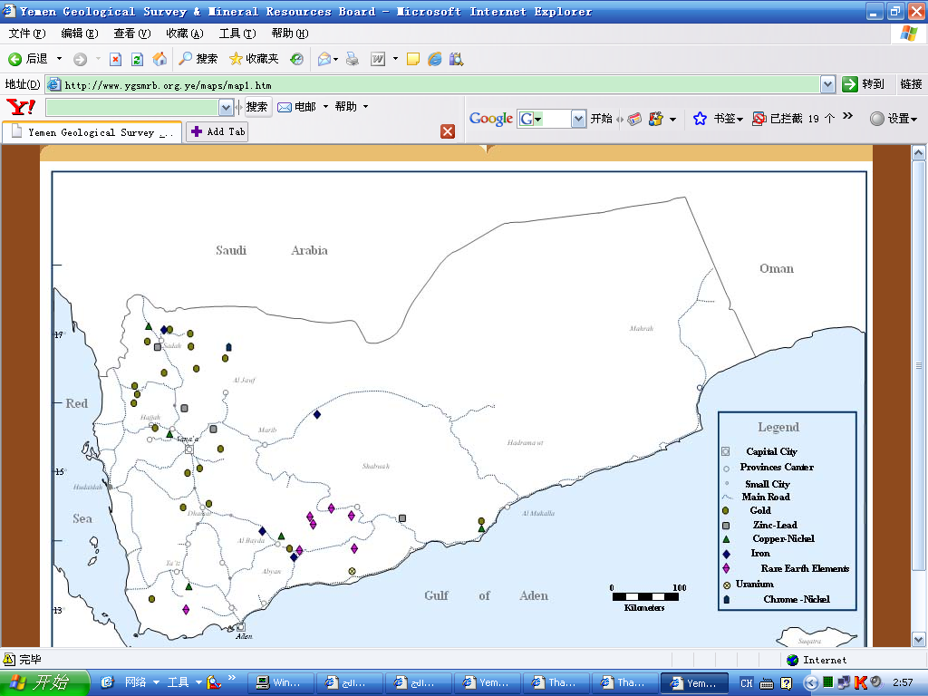

**Fig.1.5 Topographical map showing the distribution of metallic minerals in Yemen**

**(modified GSMRB, 2012)**

## 1.4 Review of research

### 1.4.1 Research objectives

This study on Wadi Sharas is very useful in the case that, if study successful research, we will discover a new importance orogenic gold belt in Yemen that encourages many researchers to do more study on Wadi Sharas gold deposits and we think in the future will contribute to the recovery of the national economy of Yemen.

This thesis entitled orogenic gold in Hajjah ore province, northwestern Yemen, with emphasis on the Neoproterozoic Wadi Sharas orogenic gold deposits presents the regional and district geology, metamorphic-and structural settings, mineral chemistry, mineralization style, genesis model, and hydrothermal alteration characteristics of Wadi Sharas orogenic gold deposits. This is done in comparison with similar gold deposits worldwide. Fluid chemistry: evidence from fluid inclusions discusses the compositions of the mineralizing fluids involved in the formation of Wadi Sharas gold deposits. The geological evolution during the mineralizing event is deduced from the fluid inclusion data.

The specific objectives of the research were to:

* Compiling data from previous studies, in order to compare the characteristics of orogenic gold deposit in the Arabian-Nubian Shield.
* Mapping the distribution of the major lithologic units and mineral potential for meta-volcanosedimentary and meta-volcanic rock of Wadi Sharas.
* To substantiate the preliminary exploration work completed by the Canadian Mountain Company (CMMY), Yemeni’s geologist team and Thani Dubai Mining leading to the discovery of the gold deposit and support them documents.
* Identify and quantify the geometry of major folding, faulting and shear zones events.
* To improve the geological knowledge of the gold deposits in Wadi Sharas area of Yemen.
* Documentation of the regional geological, tectonic and structural setting, structural styles, alteration and mineralization of Wadi Sharas deposits.
* Develop a new genesis model for gold deposits in Wadi Sharas.
* Carried out the geochemistry, petrography, mineralogy, fluid inclusions, and so on and finished write my thesis.

### 1.4.2 Motives for study

In 2007, after I have finished my Master's thesis at Jilin University, China. I have been back to Yemen, and I found that they had discovered a new target in 1996 related to gold deposits in Wadi Sharas at Hajjah province, northwestern Yemen by Canadian Mountain Company, Yemen's geological teams and Thani Dubai Mining.

Hajjah greenstone belt samples in Wadi Sharas inlier were selected because:

1. This belt is relatively large and thus more likely to preserve its initial gold mineralization structures.
2. The age of Nabitah deformation and plutonism occurred during a period of compression dating from about 680 to about 640 Ma concurrent with Afif terrane collision (Stoeser, 1986).

(3) The occurrence of greenstone cross-cut by gold deposit structures in this belt.

In fact, little integrated work has been undertaken to determine the structures, lithostratigraphic, and distribution of gold deposits within the geological of the region. In addition, the genesis model for Wadi Sharas gold deposits is still unresolved during the previous studies.

### 1.4.3 Structure of the hosted thesis

The thesis is divided into five chapters. The first chapter provides the general information and objectives for this work. The regional geology within Wadi Sharas of Yemen has been described in Chapter Two. The ore geology is summarized in Chapter three. The ore genesis is discussed in Chapter four. The conclusions of this study have been provided in the final chapter.

### 1.4.4 Scientific work

On a regional scale, the potential for gold exploration in Hajjah metamorphic belt is considered good. In Wadi Sharas, Companies and researchers Yemen's geological teams have, during the past couple of decades, focused on gold mineralizations. The gold deposits are still a poorly known area, with regards to exploration for orogenic gold mineralizations, but the potential for future discoveries of this type of gold deposits in Wadi Sharas is considered good.

### 1.4.5 Problems of existence

* Tectonic and structural characteristics need a better understand.
* Poorly studies on regional dynamics evolution.
* To understand the characterization of the mineralizing fluids with respect to fluid source and precipitation mechanisms.
* Ore genesis not clear.
* Genesis model unknown.

## 1.5 Research methods adoptive

### 1.5.1 Previous studies

Wadi Sharas orogenic gold deposits are located some 10 kilometers to the northeastern of Hajjah city, and situated some 260 kilometers to the west of Sana’a in the Nabitah belt (Hajjah metamorphic belt-Wadi Sharas Group). The gold deposits were discovered in 1996 by Canadian Mountain Company (CMMY) during a prospecting and detailed exploration campaign.

The geology and gold deposits of Wadi Sharas are documented, in varying degrees of detail in unpublished research documentation and companies’ reports. Some unpublished articles are discussed in this section, and other not discussed such as documentation belongs to the companies are not obtained easily. Mapping and soil geochemistry have shown that gold mineralization occurs for a distance of nearly 2 km parallel, N-NW trending zones.

In 2004-2005, rock samples were analyzed in Saudi Arabia by Yemen Geological Survey and Mineral Resource Board (YGSMRB), who divided Wadi Sharas gold deposits into three targets:

1) Alharirah, gold deposit has a highest grade approximately 17.8 g/t.

2) Wadi Sharas 1, the gold has a highest grade 22 g/t.

3) Wadi Sharas 2, the gold has a highest grade 11.7 g/t.

The detailed stratigraphic investigations, morphology, mineralogy, fluid inclusion and isotopic characterization of the gold mineralization in Wadi Sharas were without definitions.

Although the exploration work is still at a very early stage, a number of significant conclusions can be made from the geological and borehole data that have been collected during the mapping (Fig. 1.6), sampling, drilling, detailed structural interpretation of the satellite data, and the interpretation of Quickbird images that have been carried out in the past two year. The second annual report includes an overview of all the work carried out by Thani Dubai Mining during 2005-2007 of its exploration program in respect of Wadi Sharas area on the identified ore zones.

During the 2005 the emphasis was placed on defining a number of gold exploration targets in the area, and after having identified these, the work during 2006 shifted to doing preliminary exploration work on the identified ore zones. The results of the exploration work carried out during 2005-2007 are summarized below and the most important exploration findings are presented and discussed. The proposed budget and expenditure incurred to date are presented, together with the proposed exploration program and budget for the following year.

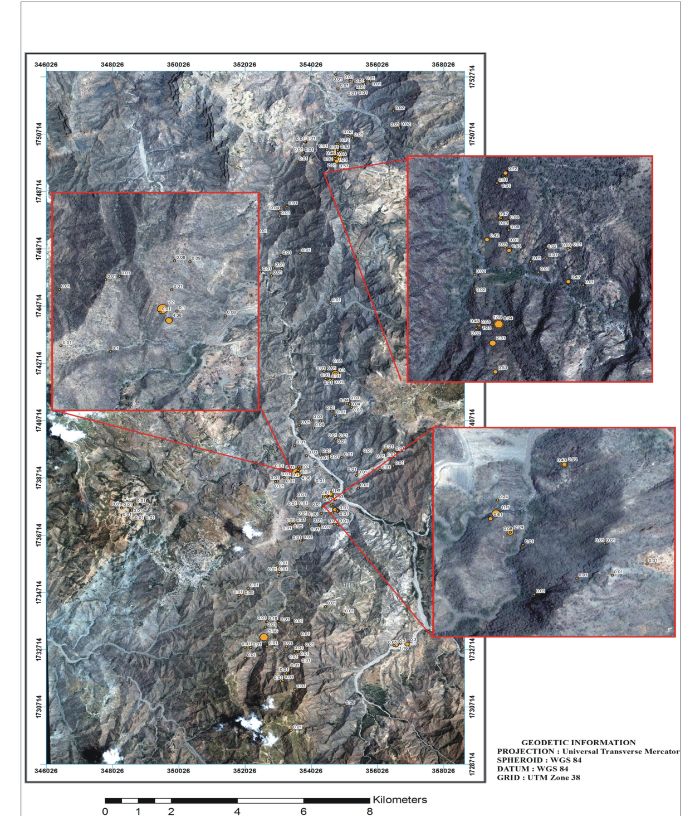

**Fig.1.6 Satellite image showing the three targets of gold mineralizations at Sharas district** (**modified after Thani Dubai Mining, 2005)**

The work carried out to date has revealed the presence of extended sulphide-bearing zones that extends from Wadi Sharas 2 in the south to Wadi Alharirah in the north over a distance of some 30 kilometers. Although these zones have been traced intermittently over this distance, the data still does not reveal the presence of a proven mineable gold reserve, but it show that a continuous mineralized zones over the entire length of the inlier is present. The exploration work thus far only focused on some areas in the northern-most first four kilometers of strike length of the sulphide zones. A second zones, more or less parallel to the sulphide zones have also been observed in the south at Wadi Sharas 1 and have been traced for in excess of some 10 km further northwards towards Wadi Alharirah. North of Wadi Alharirah these zones have been observed in the field and also in some of the reconnaissance boreholes that were drilled (Frick et al, 2007).

We can explain briefly the previous studies as follow:

* In 1996-2002, Canadian Mountain Company (CMMY) discovered Wadi Sharas gold deposits, and Wadi sediments and wholerock were collected and analyzed in Canada.
* In 2004-2005 rock samples were analyzed in Saudi Arabia by Yemen Geological Survey and Mineral Resource Board (YGSMRB).
* In 2005-2011, Thani Dubai Mining Limited (TDML) has gotten an exploration license for Wadi Sharas gold deposits and the results of the exploration work carried out during the 2005-2008 by Thani Dubai Mining are summarized below :
  + The SPOT and ASTER and LANDSAT images for Wadi Sharas study area were acquired.
  + Used Quick Bird Satellite Images Scale, to produce 1:2000 and 1:1000 interpreted geological map.
  + Map the distribution of the major and minor shear zones.
  + Doing Systematic Grid and Channel Sampling.
  + Map of the lithologies units.
  + Portray all the historic gold, silver, arsenic and mercury analyses for Wadi Sharas.
  + Linking between mineralization outcrops
  + Drilling boreholes and Trenching.

Previous studies of map features in Wadi Sharas have used stress-mapping techniques (C. Frick 2007), shape analysis and prospectivity analysis involving fuzzy logic (2006).

All the available geological, lithological and chemical data were plotted on the images and the data were used to:

* Carry out a systematic structural analysis of the area, including an assessment of the internal structure of the shear zones. The images clearly show that the shear zones are marked by intensive shearing and the disruption of the different meta-sedimentary lithologies to form small ellipsoid orientated lenses parallel to the strike of the shear zone. In addition, the images show the presence of relative high densities of silicate bands within the shear zone, which coincide with elevated gold concentrations.
* Carry out a systematic geological mapping of the different lithological unites within the shear zone on a scale of 1:2000, which was in part based on the lithological data collected in the field as well as the spectral contrasts observed in the images.
* Correlate the zones with high gold concentrations with the structural and lithological elements.

### 1.5.2 Recent studies and methodology

This section provides descriptions of the methods used in this study to investigate and quantify the geological features represented on a map of Wadi Sharas inlier. Methods include fluid inclusion, petrographical, mineralogical and geochemical characteristics. This is especially important in testing the ore genesis.

**（1）Field-based studies**

Fieldwork was carried out between September and October 2007, a total of 30 days were spent based at Wadi Sharas in Hajjah City. Approximately two-third of this time was spent visiting gold deposits, collecting samples and mapping. The acquisition of regional geological data provides the evidence necessary to interpret the results of the GIS-analysis and to help determine the potential causes for the distribution of gold mineralization. Such data include all aspects of the study that involved field observations and sample collection, as outlined below:

1）Sampling of medium-grade gold intersections.

2）Determination of the large-scale shear zones and faults.

3）Doing surface mapping at a scale of 1:2,000.

4）Sampling of rock of the greenschist and amphibolite across the study area and determination of the nature and intensity of the deformation within specific granitoid.

**The rock samples were collected from Wadi Sharis**

1- Trace elements (previous studies) 138 samples

2- Ten samples in 2008 (recent study) 10 samples

3- Eight samples in 2009 (recent study) 8 samples

4- twenty one in 2010 (recent study) 21 samples

----------

Total 178 samples

**Table1.1 Showing workload in Wadi Sharas, Yemen**

|  |  |
| --- | --- |
| **Field Work** | **Wadi Sharas** |
| Field survey | 30 days |
| Deposits and occurrences | 3 targets and 50 occurances |
| Geologic map | Scale 1:250 000, 1: 100 000 and 1:2500 |
| Geological section | Scale 1:25 |
| Rock and mineral specimens | 178 samples |
| Diamond drill cores | 9 boreholes |
| Thin-section | 11 samples |
| Polished thin-section | 29 samples |
| Temperature and composition of fluid inclusions samples | 6 pieces |
| Major and REE samples | 4 samples |
| Trace elements samples (ore) | 8 samples |

**（2）Laboratory and office work**

A significant amount of time was spent on laboratory and office-work in this study. Such work helped provide the analytical frame work for the GIS and interpretation of geological data acquired from the field. The laboratory and office-work involved:

1）Conversion of geological data to GIS format.

2）Optical polished-thinsection petrography, thinsection and Scanning Electron Microscope work on ore samples collected from medium-grade gold.

3）Reinterpretation of geochemical signature of metamorphic rocks and provision of new geochemical data.

4）Determination of the geochemical signature of gold mineralization.

5）Geochemistry analysis.

6）Fluid inclusions and thermometric analysis.

7）Determination of ore genesis and genesis model.

## 1.6 Terminology

The following abbreviations are used consistently throughout the thesis:

Ank: ankerite Pl: plagioclase

Ap: apatite Po: pyrrhotite

Apy: arsenopyrite Py: pyrite

Au: native gold Pz: petzite

BIF: banded iron formation Qz: quartz

Brt: barite Ser: sericite

Bt: biotite Sch: scheelite

Cal: calcite SEM: Scanning Electron Microscope

Cp: chalcopyrite Sp: sphalerite

Ch: chlorite Stb: stibnite

Chr: chromite To: tourmaline

Dol: dolomite

Dlt: dolerite

Gn: galena

Kf: K-feldspar

LA-ICP-MS: Laser Ablation

Inductively Coupled Plasma

Mass Spectrometry

Mt: magnetite

Mo: molybdenite

Mu: muscovite

# CONCLUSIONS

The present study documents two populations of visible and invisible gold in arsenian and pyrite at Wadi Sharas Carlin-type gold deposit.

The orogenic gold particles scattered either in the arsenian pyrite or in hollows of arsenian pyrite disseminated may have formed by dissolution and remobilization of gold-bearing arsenian pyrite.

I have aimed to describe and classify the gold deposits in Wadi Sharas, not otherwise described in this volume, according to their field characteristics. The Wadi Sharas contains three biggest targets of orogenic gold deposits, together with fifty of small-to intermediate-sized deposits and occurrences. The mineralization is commonly sub-parallel to the layering within a fructures.

A new model was developed by the author (2011), which shown that the mineralization is epigenetic in all cases, as the gold mineralization is confined to quartz veins.

Regardless of the actual mechanism of gold deposition, the ore samples used in this study provide evidence that gold deposition was accompanied by decarbonation, silicification and sulfidation.

Ore zones and associated subtle alteration zones comprise mineral assemblages typical of oxidised mesozonal orogenic gold deposits in moderate-grade metamorphic Afif terrane in the southwestern of the Arabian Shield.

Gold was potentially precipitated from a chemically evolving hydrothermal fluid, contemporaneous with deposition of sulfide minerals. Gold mineralisation at Wadi Sharas was then reworked and overprinted by a hydrothermal event during Neoproterozoic orogenesis, which resulted in deposition of subeconomic base metal mineralisation within higher level brittle–ductile fault zones.

Based on the data presented above, interpretation of the vein system and detailed petrography of the fluid inclusion assemblages associated with gold mineralization at Wadi Sharas gold deposit leads to the following preliminary conclusions:

1. According to the recent study, the ore-controlling structures, geochemiscal interpretation, type of deposits, genesis model and the timing of gold mineralization, show that Wadi Sharas deposit is a fault-shear zone vein controlled orogenic gold deposit at medium depth in the crust crosecutting the Neoproterozoic meta-volcanic and meta-volcanosedimentary, which were jointly folded and metamorphosed under greenschist and amphibolite facies conditions at about 2.3-1.3 Ga.
2. In Wadi Sharas, orogenic gold mineralization took place at temperatures between 180 and 380 °C and between 400-600 MPa from low to moderate salinity fluids containing approximately 1-22 wt.% NaCl corresponding to depths of 6-7 km. Mylonite style mineralization occurred between 330 and 360 °C and at 3- 4kbars from similar low salinity, moderately CO2-rich fluids.
3. Based on the study on fluid inclusions, the formation of Wadi Sharas deposit is mainly controlled by fluid mixing with low- and moderate- salinities at mesothermal temperatures. The fluid with relatively high salinity may be sourced from the magmatic water, while the fluid with relatively low salinity from meteoric water.
4. Gold mineralization in Wadi Sharas related to epigenetic origin hosted in fracture zone crosscutting different stratigraphical units, there might not be any relationships between metamorphic grades and gold ore formation.
5. In Wadi Sharas area the deposits and prospects of gold are entirely confined to a 30 km-long 2-4 km wide and has an average gold of 0.5-7.88 g/t
6. Gold deposit of Wadi Sharas, even being poor explored show moderate gold mineralization, thus exploration of the deposit must be perform to reveal its real economic potential.

# CONTENTS

CHAPTER 1 INTRODUCTION 1

1.1 Introduction 1

1.2 Topographical and climatic features 3

1.3 Location of the study area (Wadi Sharas) 6

1.4 Review of research 7

1.4.1 Research objectives 7

1.4.2 Motives for study 8

1.4.3 Structure of the hosted thesis 9

1.4.4 Scientific work 9

1.4.5 Problems of existence 9

1.5 Research methods adoptive 9

1.5.1 Previous studies 9

1.5.2 Recent studies and methodology 13

1.6 Terminology 15

CHAPTER 2 REGIONAL GEOLOGY 16

2.1 Introduction 16

2.2 Regional geology 16

2.3 Geology of Wadi Sharas area 22

2.4 Geochemistry analysis 25

2.4.1 Sample selections 25

2.4.2 Geology of mineralized (drilled) zone 28

2.4.3 Regional magmatic rocks 31

2.4.4 Supracrustal rocks and tectonic discrimination 38

2.4.5 Metamorphism in the deposit area 41

CHAPTER 3 ORE GEOLOGY 45

3.1 Introduction 45

3.2 Definition of orogenic gold deposit (Mesothermal) 46

3.3 Geological setting of Wadi Sharas orogenic gold deposit 48

3.3.1 Stratigraphical and structural evolution 48

3.3.2 Structural controls on gold mineralization (fault and Shear zone) 49

3.4 Gold deposit 52

3.5 Orebodies 53

3.6 Ore texture and structures 56

3.7 Ore type and ore alteration 57

3.8 Mineral association combination 58

3.9 Ore mineral and chemical composition 59

3.10 Wallrock alteration 60

3.11 Mineral stages and paragensis 62

3.12 Mineralogy of ore and gangue minerals 63

3.13 Geometrical relationships and relative timing 63

3.14 Styles and distribution of mineralization 64

3.14.1 Gold deposits in quartz veins 65

3.14.2 Gold deposits of disseminated sulfides and quartz veinlets 69

3.15 Mineralogy and mineral chemistry 72

3.15.1 Analytical Methods 73

3.15.2 Mineralogy of native gold in D3 stage 74

3.15.3 Mineralogy of arsenopyrite in D3 stage 74

3.15.4 Mineralogy of pyrite 77

3.15.5 Other minerals present in the veins and/or alteration zones 78

3.13.5 Oxides, carbonates and other minerals 79

CHAPTER 4 ORE GENESIS AND GENESIS MODEL 81

4.1 Introduction 81

4.2 Characteristics of orogenic gold deposit 82

4.2.1 Characteristics of orogenic gold deposit of Wadi Sharas 84

4.2.2 Occurrences of gold mineralization in Wadi Sharas 86

4.3 Geodynamic setting of Wadi Sharas deposits 87

4.4 Genesis model for Wadi Sharas gold deposit 88

4.4.1 Tectonic model and dynamic evolution of Wadi Sharas 90

4.5 Source of ore fluids in Wadi Sharas orogenic gold deposit 94

4.5.1 Paragenesis of quartz, carbonate, and clay minerals 94

4.5.2 Fluid inclusion studies 94

CHAPTER 5 CONCLUSIONS 105

REFRENCES 107

Figure plates and descriptions 119

The Author publication 132

Acknowledgement 133